

LEGAL OBSTACLES
The two main legal obstacles to reimbursing employees’ Medicare premiums are:
- The MSP Rules; and
- Restrictions on employer payment plans under the ACA.
COMPLIANCE TIPS
- Employers with 20 or more employees should not pay employees’ Medicare premiums. Doing so would put employers at risk for violating the MSP Rules.
- Small employers with fewer than 20 employees may be able to pay employees’ Medicare premiums if the arrangement complies with other legal restrictions, including the ACA.

Provided by Synergy Solutions Group of Virginia

Paying Employees’ Medicare Premiums
Employers that sponsor group health plans and have employees who are Medicare-eligible may be interested in reimbursing their employees’ Medicare premiums. In general, when an employee is eligible for Medicare due to age, an employer may reimburse his or her Medicare premiums only when:
- The employer’s group health plan is a secondary payer to Medicare because the employer has fewer than 20 employees; AND
- The reimbursement arrangement complies with the Affordable Care Act (ACA) because it is integrated with the employer’s group health plan (or covers fewer than two employees).
In addition, depending on how the arrangement is structured, encouraging employees to waive group health plan coverage may raise other legal concerns, such as age discrimination concerns under the federal Age Discrimination in Employment Act (ADEA). Employers that are considering reimbursing employees’ Medicare premiums may wish to consult with legal counsel to confirm that the arrangement will comply with applicable laws.
Links And Resources
- MSP Rules: More information on the MSP provisions is available on the Centers for Medicare & Medicaid Services (CMS) website, including the Medicare Secondary Payer Manual.
- ACA Restrictions: For information on the ACA’s restrictions for employer payment plans, see IRS Notice 2015-17.

MEDICARE SECONDARY PAYER rules
The Medicare Secondary Payer (MSP) rules are designed to shift costs from the Medicare program to private sources of payment (such as employer-sponsored group health plans) in certain situations. The MSP provisions govern the coordination of benefits rules for determining when an employer-sponsored group health plan will pay primary or secondary to Medicare.
The MSP provisions vary based on a number of factors, including the source of the other health coverage and why an individual is entitled to Medicare (for example, age, disability or end-stage renal disease). This discussion focuses on the MSP rules for employer-sponsored group health coverage for employees (or their spouses) who are entitled to Medicare due to age.

Primary Payer Status
Medicare pays secondary to an employer-sponsored group health plan for individuals age 65 or older who have group health plan coverage as a result of:
- Their own current employment status with an employer with 20 or more employees; or
- The current employment status of a spouse of any age with an employer with 20 or more employees.
The 20-employee threshold is met if an employer has 20 or more full-time and/or part-time employees for each working day in each of 20 or more calendar weeks in the current or preceding year. Aggregation rules apply for companies that have common ownership.
SITUATION | EMPLOYER SIZE | PAYS FIRST | PAYS SECOND
Individuals age 65 or older who are covered by a group health plan because they (or their spouses) are still working | 20 or more employees | Group health plan | Medicare
 | Fewer than 20 employees | Medicare | Group health plan

Restrictions
Due to their primary payer status, employers with 20 or more employees that sponsor group health plans must comply with the following requirements:
The group health plan must provide a current employee (or a current employee’s spouse) who is age 65 or older with the same benefits, under the same conditions, that are provided to employees and spouses who are under age 65;
The group health plan cannot take into account the Medicare entitlement of a current employee (or a current employee’s spouse); and
The employer cannot offer any financial or other incentive for a Medicare-entitled individual not to enroll (or to terminate enrollment) under a group health plan which would be a primary plan if the individual was enrolled.
Small employers (fewer than 20 employees) are not subject to these restrictions because Medicare has primary payer status.

Cannot Offer Incentives
Medicare beneficiaries are free to reject employer plan coverage, in which case they retain Medicare as their primary coverage.
However, when Medicare is the secondary payer, employers cannot discourage employees from enrolling in their group health plans.
Also, employers cannot offer any “financial or other incentive” for an individual entitled to Medicare “not to enroll (or terminate enrollment) under” a group health plan that would pay primary.
A violation of the prohibition on offering incentives can trigger financial penalties of up to $5,000 per violation.

Prohibition on Offering Certain Incentives

CMS has advised that an employer cannot offer, subsidize or be involved in the arrangement of a Medicare supplement policy where the law makes Medicare the secondary payer. Because this type of arrangement takes into account the Medicare entitlement of the employee, CMS has warned that it would subject the employer to possible excise taxes under the Internal Revenue Code.
Key Point
Unless the small employer exception applies, paying an employee’s Medicare premiums (Part B, Part D or supplement policy) likely violates the prohibition on an employer offering a financial incentive not to enroll in a group health plan that would otherwise pay primary to Medicare.

ACA Reforms

Employer Payment Plans
In the past, many employers have helped employees pay for individual health insurance policies instead of offering employer-sponsored plans. The Departments of Labor, Health and Human Services and the Treasury (Departments) have released several pieces of guidance addressing how the ACA’s market reforms impact these arrangements. The Departments’ guidance specifically addresses “employer payment plans,” under which an employer reimburses or pays premiums for an employee’s individual health insurance policy.
According to the Departments’ guidance, employer payment plans do not comply with several ACA market reforms that took effect beginning in 2014. Violations of these market reforms can result in excise taxes of $100 per day for each employee.
On Feb. 18, 2015, the IRS issued Notice 2015-17. This notice reiterates that employer payment plans are group health plans that will fail to comply with the ACA’s market reforms unless they are integrated with a group health plan that complies with the ACA’s reforms.

Medicare Premium Reimbursement
Notice 2015-17 notes that an arrangement under which an employer reimburses (or pays directly) for some or all of Medicare Part B or Part D premiums for employees constitutes an employer payment plan. If the arrangement covers two or more active employees, it is a group health plan subject to the ACA’s market reforms. An employer payment plan cannot be integrated with Medicare in order to satisfy the ACA’s market reforms, because Medicare coverage is not a group health plan for integration purposes. However, an employer payment plan that pays for or reimburses Medicare Part B or Part D premiums will satisfy the ACA’s market reforms if it is integrated with another group health plan offered by the employer.
An employer’s Medicare premium reimbursement program is considered integrated with another group health plan offered by the employer if all of the following conditions are met:
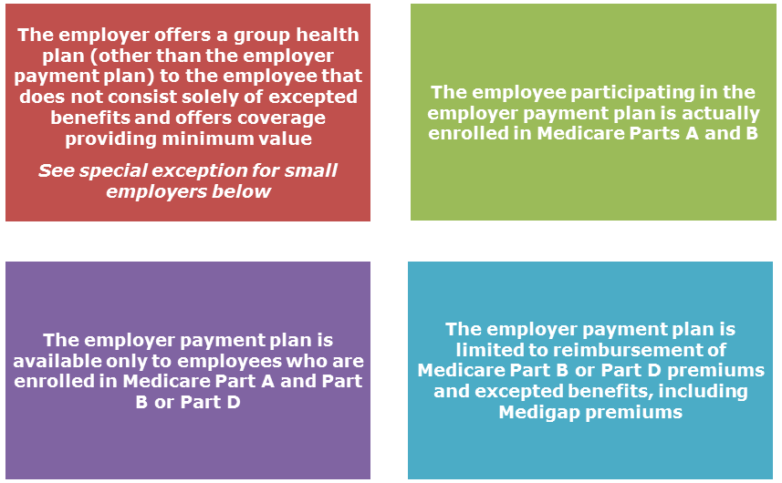
An employer payment plan that has fewer than two participants who are current employees (for example, a retiree-only plan) on the first day of the plan year is not subject to the ACA’s market reforms, and, therefore, integration is not necessary to satisfy the market reforms.
Notice 2015-17 cautions employers that this type of employer payment plan must also comply with the MSP rules. As explained above, unless the small employer exception applies, an employer that pays or reimburses current employees’ Medicare premiums likely violates the MSP prohibition on offering a financial incentive not to enroll in a group health plan that would otherwise pay primary to Medicare.

Special Exception for Small Employers
It may be difficult for employers with fewer than 20 employees to satisfy the integration requirements of Notice 2015-17. These employers are not required by the MSP rules to offer group health plan coverage to their employees who are eligible for Medicare coverage. Also, some issuers do not allow these small employers to offer group health plan coverage to their employees who are eligible for Medicare coverage.
In response to these concerns, a final rule from Nov. 18, 2015, provides a special exception for employers with fewer than 20 employees that are not required to offer their group health plan coverage to their Medicare-eligible employees and that offer group health plan coverage to their employees who are not eligible for Medicare but not to their employees who are eligible for Medicare coverage. For these employers, a premium reimbursement arrangement for Medicare Part B or D premiums may be integrated with Medicare for purposes of satisfying the ACA’s market reforms, if the employees who are not offered the other group health plan coverage would be eligible for that group health plan if not for their eligibility for Medicare.
The final rule is effective for plan years beginning on or after Jan. 1, 2017.

